**ATTENTION ALL IMHA MEMBERS**

IMHA will be continuing with the 2020/2021 Phase 2 with an 8 Week Development similar to our current protocols. Once again this will be offered in accordance with the OHF Return to Play Protocols, the current Local Health Unit recommendations and the measures put in place by Middlesex Centre for our facilities.

**Phase 2 Payment (For Players that Participated in Phase 1)**

* Phase 2 Payment will open Friday, November 6, 2020 in PlayPay ([www.playpay.ca](http://www.playpay.ca))
* Phase 2 Payment Fee will be $300.00
* Phase 2 Payment will close Sunday, November 15, 2020 @ Midnight.
* ***Any returning player that has not completed payment by November 15, 2020 @ Midnight will be considered late and will not be guaranteed a spot in Phase 2.***

**Returning Players Payment Procedures for Phase**

If you want to make any changes to activities already selected for each player in your PlayPay account (under ‘my organizations’), or add new activities that are now listed, please follow the instructions;

* In your PlayPay account, click ‘my organizations’.
* For the specific player, click the change hyperlink in the Activities column.
* Make the required changes and/or add new activities, when completed click the ‘Save Activities’ button.
* Repeat as required for each player.

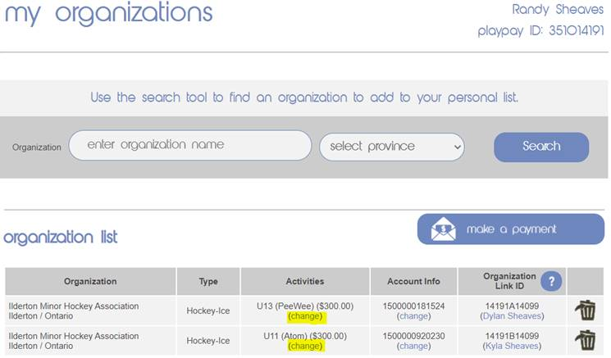

**Phase 2 Registration & Payment (For Players that DID NOT Participate in Phase 1)**

* Phase 2 Registration & Payment for players that DID NOT Participate in Phase 1 will open Thursday, November 19, 2020 and will be accepted based on the spots available in the age group the player is registering for. Please note that the number of available spots will be influenced by restrictions in place concerning the number of on ice participants and the ice times available to IMHA.
* Phase 2 Registration and Payment procedure will be posted on November 19, 2020 for players that did not participate in Phase 1.

If you require assistance or encounter any online payment issues, please email our current Treasurer @ [treasurer@ildertonjets.com](mailto:treasurer@ildertonjets.com)

Best Regards

IMHA Executive